Priyal Makwana TY04/B_35 23UF17826CM156 EXP02

STAR SCHEMA
CODE:
CREATE TABLE Time_Dim (
time_id NUMBER PRIMARY KEY, day NUMBER,
month NUMBER, year NUMBER, sales_date DATE
);
CREATE TABLE Product_Dim ( product_id NUMBER PRIMARY KEY, product_name VARCHAR2(100), brand VARCHAR2(50),
category VARCHAR2(50), price NUMBER(10,2)
);
CREATE TABLE Branch_Dim ( branch_id NUMBER PRIMARY KEY, branch_location VARCHAR2(100), contact_no VARCHAR2(15), manager VARCHAR2(50),
city VARCHAR2(50)
);
CREATE TABLE Location_Dim ( location_id NUMBER PRIMARY KEY, state VARCHAR2(50),
city VARCHAR2(50),
country VARCHAR2(50), region VARCHAR2(50)
);
CREATE TABLE Sales_Fact ( sales_id NUMBER PRIMARY KEY, time_id NUMBER,
product_id NUMBER, branch_id NUMBER, location_id NUMBER, total_sales NUMBER(12,2), units_sold NUMBER,

CONSTRAINT fk_time FOREIGN KEY (time_id) REFERENCES Time_Dim(time_id),
CONSTRAINT fk_product FOREIGN KEY (product_id) REFERENCES Product_Dim(product_id), CONSTRAINT fk_branch FOREIGN KEY (branch_id) REFERENCES Branch_Dim(branch_id),

CONSTRAINT fk_location FOREIGN KEY (location_id) REFERENCES Location_Dim(location_id)
);
SELECT table_name FROM user_tables;

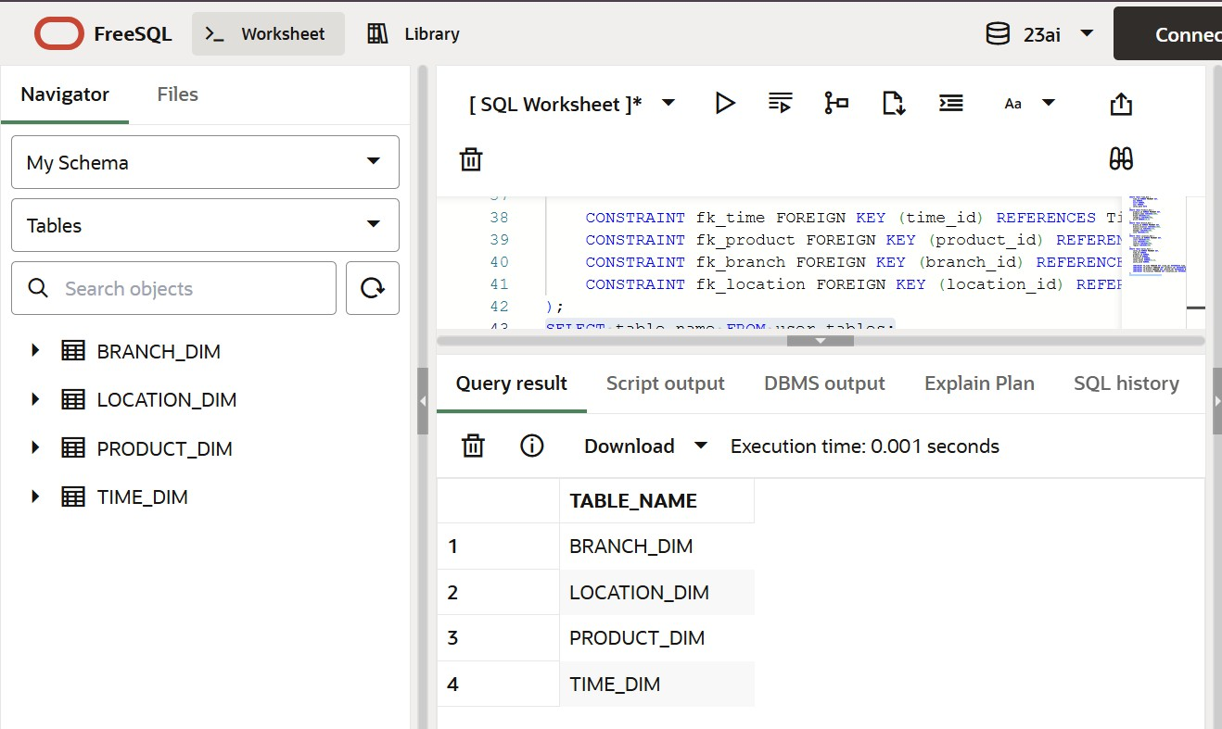
OUTPUT:

SNOWFLAKE SCHEMA
CODE:
CREATE TABLE Country_Dim ( country_id NUMBER PRIMARY KEY, country_name VARCHAR2(50)
);
CREATE TABLE Location_Dim_SF ( location_id NUMBER PRIMARY KEY, country_id NUMBER,
region VARCHAR2(50), pincode VARCHAR2(10),

CONSTRAINT fk_country FOREIGN KEY (country_id)
REFERENCES Country_Dim(country_id)
);
CREATE TABLE Branch_Dim_SF ( branch_id NUMBER PRIMARY KEY, branch_name VARCHAR2(50), location_id NUMBER,

CONSTRAINT fk_location_sf FOREIGN KEY (location_id)
REFERENCES Location_Dim_SF(location_id)
);
CREATE TABLE Time_Dim_SF ( time_id NUMBER PRIMARY KEY, day NUMBER,
month NUMBER, year NUMBER
);
CREATE TABLE Product_Dim_SF ( product_id NUMBER PRIMARY KEY, product_name VARCHAR2(100), price NUMBER(10,2)
);
CREATE TABLE Sales_Fact_SF ( sales_id NUMBER PRIMARY KEY, time_id NUMBER,
product_id NUMBER, branch_id NUMBER, units_sold NUMBER,

CONSTRAINT fk_time_sf
FOREIGN KEY (time_id) REFERENCES Time_Dim_SF(time_id),

CONSTRAINT fk_product_sf
FOREIGN KEY (product_id) REFERENCES Product_Dim_SF(product_id),

CONSTRAINT fk_branch_sf
FOREIGN KEY (branch_id) REFERENCES Branch_Dim_SF(branch_id)
);
SELECT table_name FROM user_tables;

OUTPUT:

CREATE TABLE Dim_Customer (
customer_id INT PRIMARY KEY,
customer_name VARCHAR(50),
city VARCHAR(50),
state VARCHAR(50),
country VARCHAR(50)
);

CREATE TABLE Dim_Product (
product_id INT PRIMARY KEY,
product_name VARCHAR(50),
category VARCHAR(50),
brand VARCHAR(50)
);

CREATE TABLE Dim_Time (
time_id INT PRIMARY KEY,
day INT,
month INT,
year INT
);

Review Questions:
Q1. In a star schema, how is the fact table typically related to the dimension tables?
Answer:
In a star schema, the fact table is directly connected to each dimension table using foreign keys. Each dimension has a one-to-many relationship with the fact table, forming a star-like structure.

Q2. What is the main difference between a star schema and a snowflake schema?
Answer:
The main difference is normalization:
- A star schema uses denormalized dimension tables, resulting in simpler queries and faster performance.
- A snowflake schema uses normalized dimension tables, reducing data redundancy but increasing query complexity.
